**Data Quality Report**

High-level description:

This is a DQR on a dataset provided by the Stakeholder for New York Property Tax fraud analysis. It has 1070994 rows and 32 fields. It covers the period 2010/11.

Field summary:

Numeric Type Fields:

|  |  |  |  |  |  |  |
| --- | --- | --- | --- | --- | --- | --- |
| Field Name | % Populated | Min Val | Max Val | Mean | StdDeviation | % Zeros |
| LTFRONT | 100 | 0 | 9999 | 36.6 | 74 | 169108 |
| LTDEPTH | 100 | 0 | 9999 | 88.8 | 76.3 | 170128 |
| STORIES | 94.7 | 1 | 119 | 5 | 8.4 | 0 |
| FULLVAL | 100 | 0 | 6150000000 | 874264.5 | 11582431 | 13007 |
| AVLAND | 100 | 0 | 2668500000 | 85068 | 4057260 | 13009 |
| AVTOT | 100 | 0 | 4668308947 | 227238 | 6877529.3 | 13007 |
| EXLAND | 100 | 0 | 2668500000 | 36423.9 | 3981575.7 | 491699 |
| EXTOT | 100 | 0 | 4668308947 | 91187 | 6508402.8 | 432572 |
| BLDFRONT | 100 | 0 | 7575 | 23 | 35.5 | 228815 |
| BLDDEPTH | 100 | 0 | 9393 | 39.9 | 42.7 | 228853 |
| AVLAND2 | 26.4 | 3 | 2371005000 | 246235.7 | 6178962 | 0 |
| AVTOT2 | 26.3 | 3 | 4501180002 | 713911.4 | 11652528.9 | 0 |
| EXLAND2 | 8.1 | 1 | 2371005000 | 351235.6 | 10802212.6 | 0 |
| EXTOT2 | 12.2 | 7 | 4501180002 | 656768.2 | 16072510.1 | 0 |
| YEAR | 100 | 2010/11 | 2010/11 | 2010/11 |  |  |

Category Type Fields:

|  |  |  |  |
| --- | --- | --- | --- |
| Field Name | % Populated | # Unique Values | Most Common Value |
| RECORD | 100 | 1070994 |  |
| BBLE | 100 | 1070994 |  |
| BORO | 100 | 5 | 4 |
| BLOCK | 100 | 13984 | 3944 |
| LOT | 100 | 6366 | 1 |
| EASEMENT | 0.4 | 13 | E |
| OWNER | 97 | 863348 | PARKCHESTER PRESERVAT |
| BLDGCL | 100 | 200 | R4 |
| TAXCLASS | 100 | 11 | 1 |
| EXT | 33 | 4 | G |
| EXCD1 | 59.6 | 130 | 1017 |
| STADDR | 99.9 | 839281 | 501 SURF AVENUE |
| ZIP | 97.2 | 197 | 10314 |
| EXMPTCL | 1.4 | 15 | X1 |
| EXCD2 | 8.6 | 61 | 1017 |
| PERIOD | 100 | 1 | FINAL |
| VALTYPE | 100 | 1 | AC-TR |

Individual field summary:

1. RECORD: This is an identification number of the record.

1. BBLE: It is an identification number that signifies Boro, Block, Lot and Easement code.

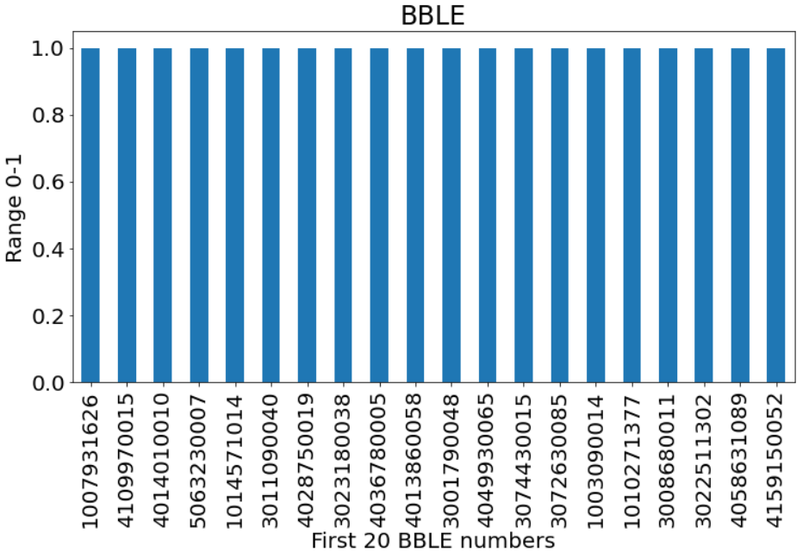

1. BORO: Stands for Borough. It has 5 values. 1 = Manhattan, 2 = Bronx, 3 = Brooklyn, 4 = Queens, 5 = Staten Island.

1. BLOCK: These are block numbers taken from the block ranges based on BORO. Manhattan: 1 to 2255, Bronx: 2260 to 5958, Brooklyn: 1 to 8955, Queens: 1 to 16350, Staten Island: 1 to 8050.

1. LOT: Indicates the LOT size with respective to each property.

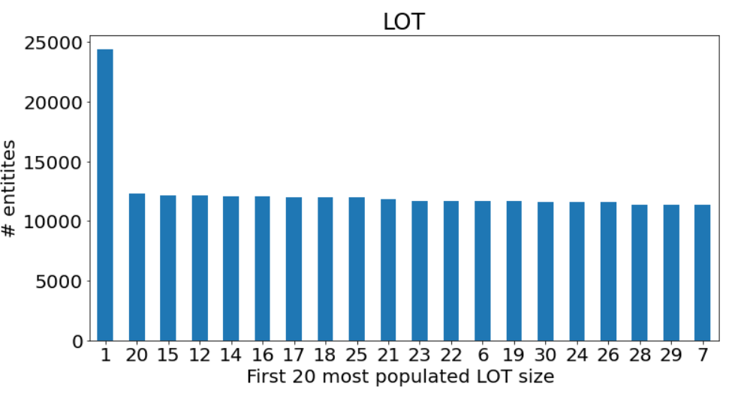

1. EASEMENT: Describes which type of Easement does the property have. Space = No Easement A = Air Easement B = Non-Air Rights E = Land Easement F Thru M are duplicates of E N = Non-Transit Easement P = Pier R = Railroad S = Street U = U.S. Government

1. OWNER: It indicates the name of the owner.

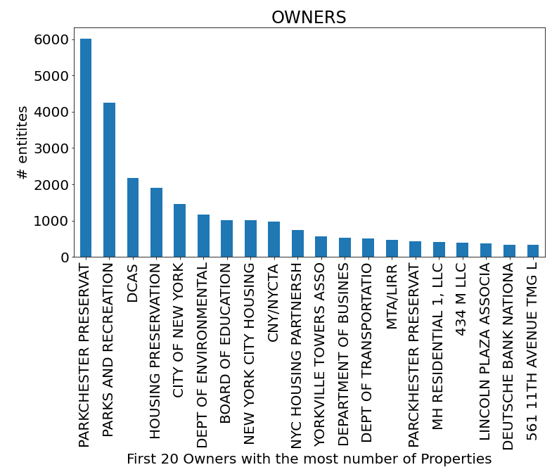

1. BLDGCL: it denotes the class of the Building.

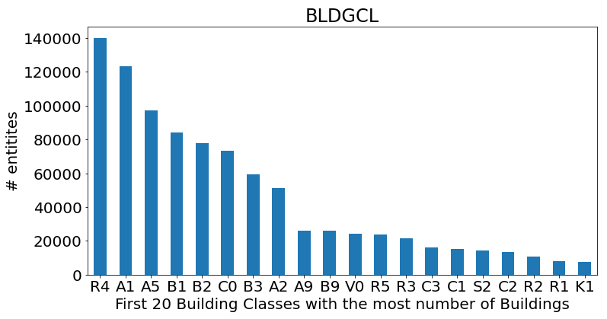

1. TAXCLASS:

1 = 1 - 3 Unit Residence, 2 = Apartments, 2A = 4, 5, or 6 Units, 3 = Utilities, 4 = All Others.

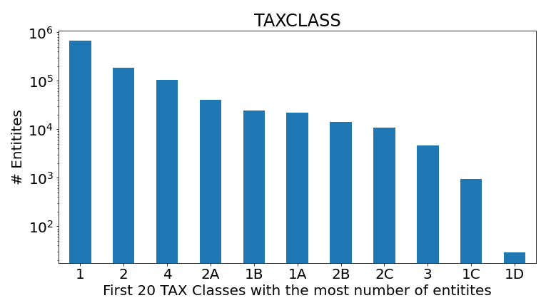

1. LTFRONT: It is the Lot Width.

The below figure uses a logarithmic scale and the Lot width is limited to 102.

1. LTDEPTH: It is the Lot Depth.

The below figure uses a logarithmic scale and the Lot Depth is limited to 710.

1. EXT: Extension Indicator

1. STORIES: Number of Stories in Building.

The below figure uses a logarithmic scale and the Stories are limited to 50.

1. FULLVAL: Market Value. 1200000

The below figure uses a logarithmic scale and displays up to a market value of 1200000.

1. AVLAND: Actual Land Value.

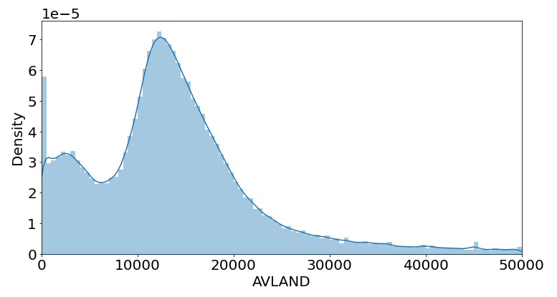

1. AVTOT: Actual Total Value

1. EXLAND: Actual Exempt Land Value

The below figure uses a logarithmic scale.

1. EXTOT: Actual Exempt Land Total

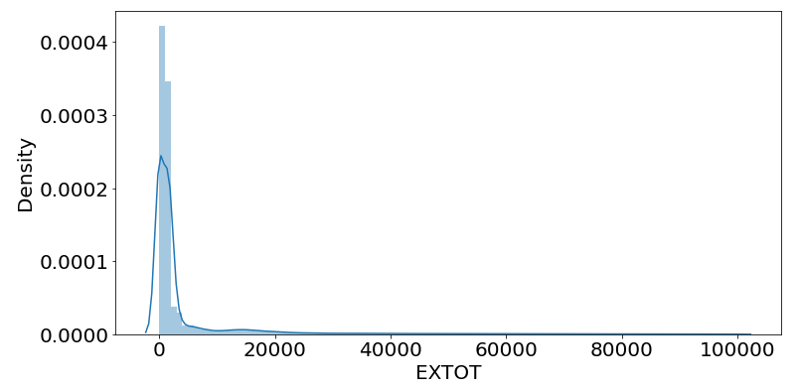

1. EXCD1: Exemption Code 1

1. STADDR: Street Address.

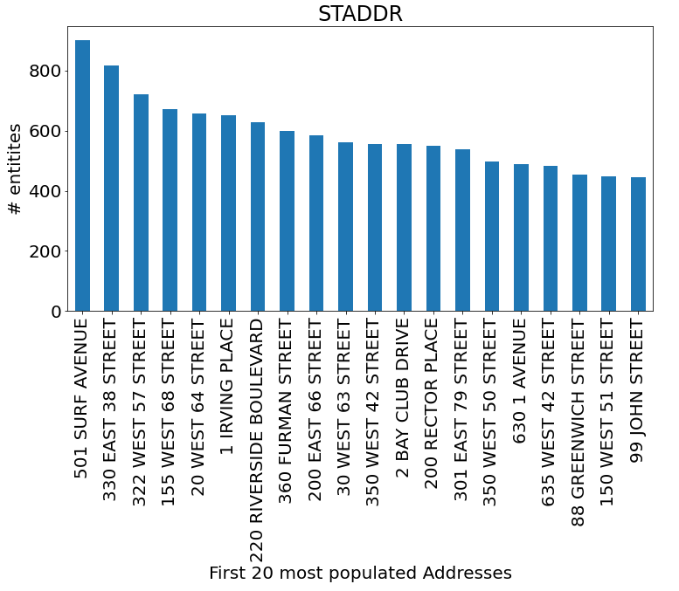

1. ZIP: ZIP code.

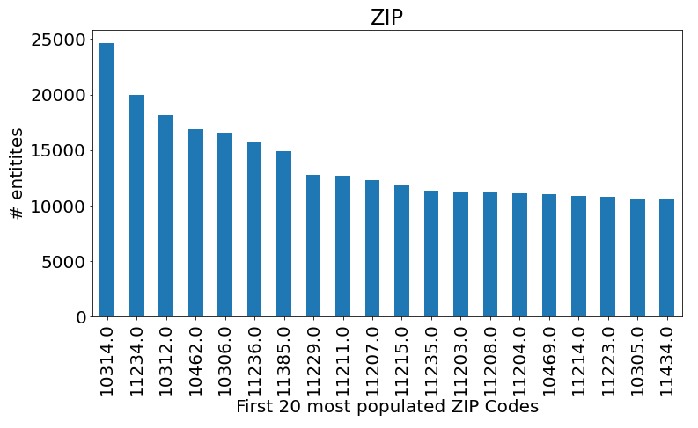

1. EXMPTCL: Exemption Class.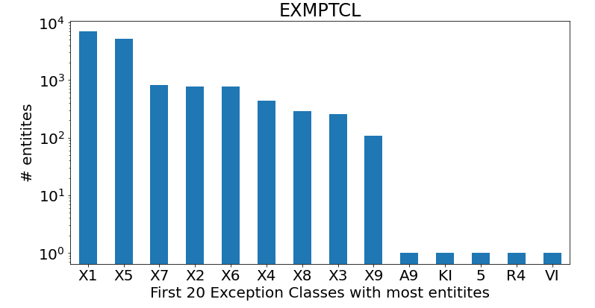
2. BLDFRONT: Building Width.

The below figure uses a logarithmic scale and displays up to a Building Width of 150.

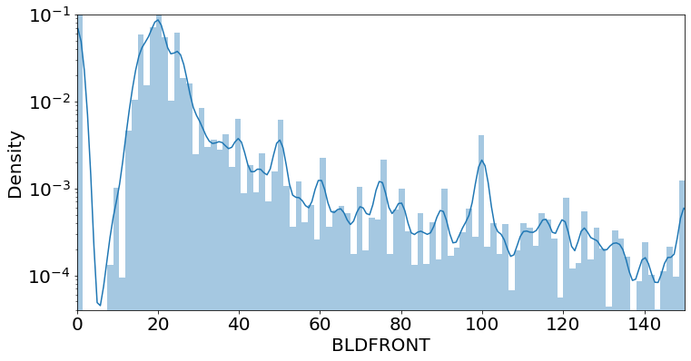

1. BLDDEPTH: Building Depth.

The below figure uses a logarithmic scale and displays Density up to a Building Depth of 100.

1. AVLAND2: Transitional Land Value.

The below figure displays number of entities up to a 3000 transitional land value.

1. AVTOT2: Transitional Total Value.

1. EXLAND2: Transitional Exemption Land Value

The below figure uses a logarithmic scale and displays Density up to an Exemption value of 50000.

1. EXTOT2: Transitional Exemption Land Total.

The below figure uses a logarithmic scale and displays Density up to an Exemption value of 300000.

1. EXCD2: Exemption Code 2.

The below figure uses a logarithmic scale.

1. PERIODL: Assessment Period. Has only one value.

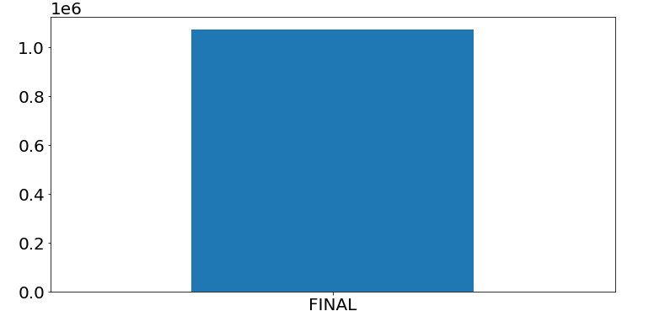

1. YEAR. Has only one value.

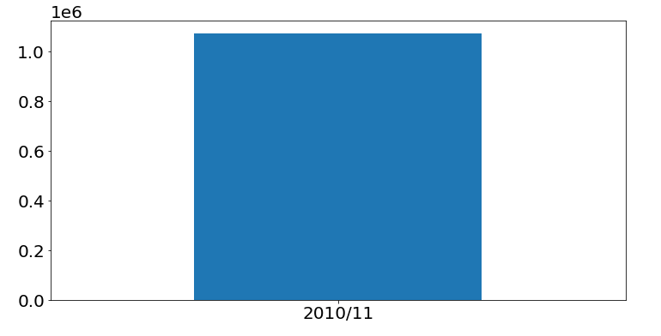

1. VALTYPE: Has only one Value.

